



INSTITUTE FOR ADVANCED COMPUTING AND SOFTWARE DEVELOPMENT AKURDI, PUNE

Documentation On

“PetShop” WebApplication

PG-DAC April 2023

**Submitted By:**

**Group No: 89**

|  |  |
| --- | --- |
| **Roll No.** | **Name:** |
| **223187** | **Pratik Shashikant Sawant** |
| **223227** | **Uddesh Balu Deshmukh** |

|  |  |
| --- | --- |
| **Mr. Rohit Puranik** | **Mrs. Monika Sindhikar and Mr. Harshal Waghchaure** |
| Centre Co-Ordinator | Project Guide |

**Table of Contents**

ABSTRACT 2

ACKNOWLEDGEMENT 3

1. INTRODUCTION 4
2. FEATURES 4
   1. PROJECT OBJECTIVE 8
   2. PROJECT OVERVIEW 4

2.3 PROJECT SCOPE 5

* 1. STUDY OF THE SYSTEM 5

2.4.1 MODULES 5

3. SYSTEM ANALYSIS 6

* 1. SYSTEM REQUIREMENT SPECIFICATION 8
     1. GENERAL DESCRIPTION 8

3.3.2 SYSTEM OBJECTIVES 9

3.3.3 SYSTEM REQUIREMENTS 9

3.3.3.1 FUNCTION REQUIREMENT 10

3.3.3.2 NON - FUNCTION REQUIREMENT 10

4. ADMINISTRATOR 11

5. SYSTEM DESIGN 12

1. INPUT AND OUTPUT DESIGN 13

6.1 INPUT DESIGN 13

6.2 OUTPUT DESIGN 13

1. DATABASE DESIGN 14
   1. DATABASE 14
2. SYSTEM TOOLS 15
   1. FRONT END 15
   2. BACKEND 15

**1 LEVEL DFD FOR ADMIN 17**

1. **LEVEL DFD FOR CUSTOMER 18**

**E-R DIAGRAM 19**

**CLASS DIAGRAM 20**

**TABLE STRUCTURE 21**

**PROJECT DIAGRAMS 23**

**CONCLUSION 23**

**REFERENCES 25**

**LIST OF FIGURES**

**FIGURE 1: ADMIN ACTIVITY DIAGRAM 17**

**FIGURE 2: SUPPLIER ACTIVITY DIAGRAM 18**

**FIGURE 3: CUSTOMER ACTIVITY DIAGRAM 19**

**FIGURE 4: DELIVERY BOY ACTIVITY DIAGRAM 20**

**FIGURE 5: 1 LEVEL DFD FOR ADMIN 21**

**FIGURE 6: 1 LEVEL DFD FOR CUTOMER 22**

**FIGURE 7: E-R DIAGRAM 23**

**FIGURE 8: CLASS DIAGRAM 23**

**FIGURE 9: TABLE STRUCTURE 16**

**Abstract**

The Pet Shop Web Application is a user-centric and admin-empowering solution designed to simplify the process of purchasing pet-related products. This platform grants customers easy access to a variety of pet items, ensuring a personalized shopping experience through authentication and customization. The application's interface is user-friendly and intuitive, catering to both new and returning customers. Users can navigate through categories, add products to their cart, and finalize their selections with a secure and swift checkout process.

Administrators are equipped with a dedicated admin portal, allowing them to oversee orders, manage inventory, and gain insights into customer behavior. This data-driven approach enhances decision-making and refines product offerings. In essence, the Pet Shop Web Application fosters a seamless shopping journey for pet owners and streamlines operations for the pet shop, contributing to the growth of the pet industry by offering modern convenience to pet enthusiasts.

**ACKNOWLEDGEMENT**

In this moment of gratitude and reflection, I am profoundly appreciative of the divine guidance and blessings that have paved the way for the successful culmination of our pet shop web application project. With genuine thankfulness, I extend my heartfelt acknowledgment to our devoted mentors**, Mrs. Monika Sindhikar and Mr. Harshal Waghchaure**. Their unwavering dedication has been a guiding beacon, leading us through challenges and illuminating the path to accomplishment.

I am equally indebted to our esteemed Centre Co-Ordinator, **Mr. Rohit Puranik**, whose generosity in providing us access to essential facilities has played a pivotal role in the realization of our project. Gratitude also extends to our revered faculty members, whose constant support and insightful counsel have been invaluable companions on this journey.

Behind every milestone achieved, there lies the unwavering support of friends and family. Their unwavering belief in our abilities has been the fuel that propelled us forward, even in the face of adversity.

In closing, this endeavor stands as a testament to collective effort and shared determination. My heartfelt thanks go out to every individual who has contributed to this voyage. Your support, guidance, and unshakeable faith in our capabilities have been the cornerstone of transforming our vision into the tangible reality of this project.

1. **INTRODUCTION**

The Pet-Shop Web Application sets out to revolutionize the way pet enthusiasts interact with the pet industry. This comprehensive document dives deep into the intricate details of the application's development journey. It emphasizes the significance of creating a user-friendly, efficient, and secure digital platform that caters to the unique needs of both customers and administrators.

1. **FEATURES**

**2.1 Product Objectives**

The primary goal of the Pet-Shop Web Application is to streamline and elevate the process of purchasing pet-related products. By combining cutting-edge technology with a user-centric approach, this application aims to create an online ecosystem that simplifies the browsing, selection, and purchase of a diverse range of pet treasures. Moreover, it seeks to provide administrators with a robust toolset for managing orders, inventory, and customer insights.

**2.2 Product overview**

The Pet-Shop Web Application aims to create an intuitive and convenient online platform that allows customers to explore, select, and purchase a diverse range of pet-related products. This application is designed to cater to the needs of pet owners and enthusiasts who are seeking high-quality products for their beloved animals. By providing a user-friendly interface, comprehensive product information, and seamless shopping experience, the Pet-Shop Web Application aims to deliver convenience and satisfaction to its users.

* 1. **Key Functionalities**

This document meticulously outlines the functionalities of the Pet-Shop Web Application. From user authentication and personalized shopping experiences to an intuitive product catalog, seamless checkout process, and comprehensive admin portal – each functionality contributes to the overall user satisfaction and operational efficiency of the application.

**2.3 SYSTEM ANALYSIS**

**2.3.1 MODULES:**

After careful analysis, the system has been organized into distinct modules, each assigned specific roles to ensure a seamless operation. The identified modules are:

* Administrator
* Customer

**2.3.1.1 Administrator:**

The Administrator assumes the role of the application's guardian, holding ultimate authority. Often the shop owner, they enjoy comprehensive access to the admin page, enriched with insights into users and products. This module branches into sub-modules, encompassing essential functions:

**Manage Pet Products:**

This empowers the administrator to easily curate and oversee the array of pet products available for purchase. Fresh additions can be effortlessly introduced, complete with detailed descriptions, images, and attributes like type, size, and color.

**Manage Users:**

In the realm of user management, the administrator takes the lead. All customer details, account specifics, and interactions are centralized, facilitating personalized assistance and prompt resolution of user concerns.

**Manage Orders:**

The administrator guides the order journey from initiation to fulfillment. Orders are monitored, verified, and updated as they progress through various stages, ensuring a transparent and efficient buying experience.

**Search and Edit Products:**

Armed with an agile product search feature, the administrator can quickly locate and fine-tune product details. This agility empowers real-time adjustments to information, prices, and other attributes in response to evolving demands.

**Add New Products:**

With the power to enrich the product catalog, the administrator introduces fresh offerings in alignment with trends and preferences. Comprehensive product details and high-quality visuals elevate the shopping experience.

**2.3.1.2 Customer:**

In the world of the pet shop web application, the customer is the person looking to buy things for their pets. They can do this online, on the phone, or by visiting the store. The customer picks the pet products they want, like pet food or toys, and can choose the size and quantity they need. They also provide important information like where the stuff should be delivered, how to contact them, and how to pay. After they order, they get an idea of when the things will arrive and updates on the order's progress.

**Customer-Focused Features:**

**Account Control:**

Customers can easily sign in, sign out, and create accounts. This helps them shop smoothly and get a personal touch.

**Finding Pet Stuff:**

Customers can look for pet items they want using a search tool. They can find things in specific categories, making it easier to see what's available.

**Putting Things in a Cart:**

Customers can collect their chosen items in a virtual cart, just like a real shopping cart. It's a handy way to keep track of what they're buying.

**Paying for Orders:**

Customers can handle their payments and check the status of transactions for the things they ordered.

**Seeing Order Info:**

Customers can review all the details of their orders, making sure everything is clear and accurate.

**Personalizing Profiles:**

Customers have the power to change their profile information, keeping it up-to-date and right.

**Getting Products:**

Customers can finish their shopping by paying and getting the stuff they want from their cart.

1. **SYSTEM REQUIREMENT SPECIFICATION**

**3.1.1 GENERAL DESCRIPTION - Product Description:**

The pet shop web application consists of two primary components: a customer-centric web interface and an administrative back-end. This system aims to simplify the process of purchasing pet-related products for customers while offering efficient order management tools for the shop owner.

**Problem Statement:**

Amid the surge in online shopping trends, traditional pet shops face the challenge of competing with digital brands. Customers increasingly seek the convenience of online shopping and doorstep delivery. To adapt and thrive, pet shops can embrace technology by providing an online platform, thereby expanding their reach and offering a more accessible shopping experience.

**3.3.2 SYSTEM OBJECTIVES**

To provide a user-friendly web application: A platform where customers can explore and purchase a variety of pet-related products.

To establish an online presence: Creating an online shopping website that complements the physical store, catering to the needs of digital-savvy pet owners.

**3.3.3 SYSTEM REQUIREMENTS**

**3.3.3.1 FUNCTIONAL REQUIREMENTS**

**CUSTOMER**

**USER LOGIN:**

Customers can log in securely using their credentials for personalized shopping.

**REGISTER NEW CUSTOMER:**

New customers must register by providing essential information. The admin approves new registrations to ensure authenticity.

**EXPLORE PRODUCTS:**

Customers can browse a wide range of pet-related products categorized for easy exploration.

**ADD TO CART:**

Customers can add desired products to their cart for future purchase.

**CHECKOUT AND PAYMENT:**

Customers can proceed to checkout, providing delivery details and making secure online payments.

**3.3.3.2 NON-FUNCTIONAL REQUIREMENTS**

**i. Efficiency Requirement:**

The web application should efficiently handle customer interactions, from product selection to checkout, ensuring a seamless shopping journey.

**ii. Reliability Requirement:**

The system should offer a reliable and error-free experience, ensuring that customer orders are accurately processed, and shop owners can manage them efficiently.

**iii. Usability Requirement:**

The web application is designed to be user-friendly, enabling both tech-savvy and novice customers to navigate and make purchases effortlessly.

**iv. Implementation Requirement:**

The application will be developed using modern technologies, such as React for the front end, Spring Boot for the back end, and MySQL for database management. Responsive design ensures optimal user experience across various devices.

**v. Delivery Requirement:**

The complete system, from development to testing, is expected to be delivered within a timeframe of four months, with regular evaluations guided by the project mentor.

1. **ADMINISTRATOR**

**ADMIN LOGIN:**

The administrator can securely log in to access the administrative tools.

**MANAGE PRODUCTS:**

The admin can oversee the product catalog, adding, editing, or removing items as needed.

**ORDER MANAGEMENT:**

The admin can monitor and manage customer orders, updating statuses and ensuring timely delivery.

In the realm of the pet shop web application, these functionalities work harmoniously to create an enhanced shopping experience for customers while empowering administrators to efficiently manage operations, ultimately contributing to the growth and modernization of the pet industry.

1. **SYSTEM DESIGN**

System design is the solution for the creation of a new system. This phase focuses on the detailed implementation of the feasible system. Its emphasis on translating design. Specifications to performance specification. System design has two phases of development.

* Logical Design
* Physical Design

During logical design phase the analyst describes inputs (sources), outputs(destinations), databases (data sores) and procedures (data flows) all in a format that meets the user requirements. The analyst also specifies the needs of the user at a level that virtually determines the information flow in and out of the system and the data resources. Here the logical design is done through data flow diagrams and database design. The physical design is followed by physical design or coding. Physical design produces the working system by defining the design specifications, which specify exactly what the candidate system must do. The programmers write the necessary programs that accept input from the user, perform necessary processing on accepted data and produce the required report on a hard copy or display it on the screen.

1. **INPUT AND OUTPUT DESIGN**

**6.1 INPUT DESIGN:**

Input design is the link that ties the information system into the world of its users. The input design involves determining the inputs, validating the data, minimizing the data entry and provides a multi-user facility. Inaccurate inputs are the most common cause of errors in data processing. Errors entered by the data entry operators can be controlled by input design. The user-originated inputs are converted to a computer-based format in the input design. Input data are collected and organized into groups of similar data. Once identified, the appropriate input media are selected for processing. All the input data are validated and if any data violates any conditions, the user is warned by a message. If the data satisfies all the conditions, it is transferred to the appropriate tables in the database. In this project the student details are to be entered at the time of registration. A page is designed for this purpose which is user friendly and easy to use. The design is done such that users get appropriate messages when exceptions occur.

**6.2 OUTPUT DESIGN:**

Computer output is the most important and direct source of information to the user. Output design

is a very important phase since the output needs to be in an efficient manner. Efficient and intelligible output design improves the system relationship with the user and helps in decision making. Allowing the user to view the sample screen is important because the user is the ultimate judge of the quality of output. The output module of this system is the selected notifications

1. **DATABASE DESIGN**

**7.1 DATABASE**

Databases serve as data repositories for software systems, housing information within tables. Multiple tables are created to manipulate data for the system. Two critical aspects of a database are:

Primary Key: A unique field for all record instances.

Foreign Key: A field establishing relationships between tables. Normalization is used to minimize table redundancy.

1. **SYSTEM TOOLS**

This section delves into the system tools utilized in developing both the front end and back end of the project.

**8.1 FRONT END:**

For the front end, the project leverages React, a library developed by Facebook. React is an open-source JavaScript library that builds user interfaces and UI components. Maintained by Facebook and a community of developers, React is adept at creating single-page and mobile applications. While React excels in state management and rendering to the DOM, it often necessitates additional libraries for routing and client-side functionalities.

**8.2 BACK END:**

The back end is powered by MySQL, a relational database management system (RDBMS) that ranks as the world's second most widely used open-source RDBMS. MySQL employs Structured Query Language (SQL). Navicat, an application software, was used to design tables in MySQL.

Spring-Boot:

Spring Boot is the connecting link between MySQL and data manipulation. It retrieves and stores data in the database. Spring Framework, an application framework and inversion of control container for Java, facilitates this connection. It extends to building web applications on the Java EE platform. The Spring Framework, although adaptable to various programming models, is particularly popular as an enhancement to the Enterprise JavaBeans model. It remains an open-source framework.

By harnessing these technologies, the pet shop web application achieves a harmonious marriage between the front end and back end, culminating in a seamless and dynamic user experience while concurrently ensuring robust database management.

|  |  |  |  |  |  |
| --- | --- | --- | --- | --- | --- |
| **Fields** | **Type** | **Null** | **Key** | **Default** | **Extra** |
| category_id  category_name | Int  varchar (255) | NO  NO | PRI | NULL  NULL | auto_increment |

**Tables**

Category Table:-

Customer Table:-

|  |  |  |  |  |  |
| --- | --- | --- | --- | --- | --- |
| **Fields** | **Type** | **Null** | **Key** | **Default** | **Extra** |
| customer_id  customer_name  customer_password | int  varchar(255)  varchar(255) | NO  NO  NO | PRI | NULL  NULL  NULL | auto_increment |

Order Table:-

|  |  |  |  |  |  |
| --- | --- | --- | --- | --- | --- |
| **Fields** | **Type** | **Null** | **Key** | **Default** | **Extra** |
| order_id  dispatch_date  order_date  total_cost  customer_customer_id  products_product_id | int  date  date  float  int  int | NO  NO  NO  NO  YES  YES | PRI  MUL  MUL | NULL  NULL  NULL  NULL  NULL  NULL | auto_increment |

Product Table:-

|  |  |  |  |  |  |
| --- | --- | --- | --- | --- | --- |
| **Fields** | **Type** | **Null** | **Key** | **Default** | **Extra** |
| product_id  product_breed  category  product_cost  description  product_name | int  varchar (255)  varchar(255)  float  varchar(255)  varchar(255) | NO  YES  NO  NO  YES  NO | PRI | NULL  NULL  NULL  NULL  NULL  NULL | auto_increment |

User Table:-

|  |  |  |  |  |  |
| --- | --- | --- | --- | --- | --- |
| **Fields** | **Type** | **Null** | **Key** | **Default** | **Extra** |
| user_id  user_name  user_type  customer_customer_id | int  varchar(255)  varchar(255)  int | NO  NO  NO  YES | PRI  MUL | NULL  NULL  NULL  NULL | auto_increment |

**Diagrams**

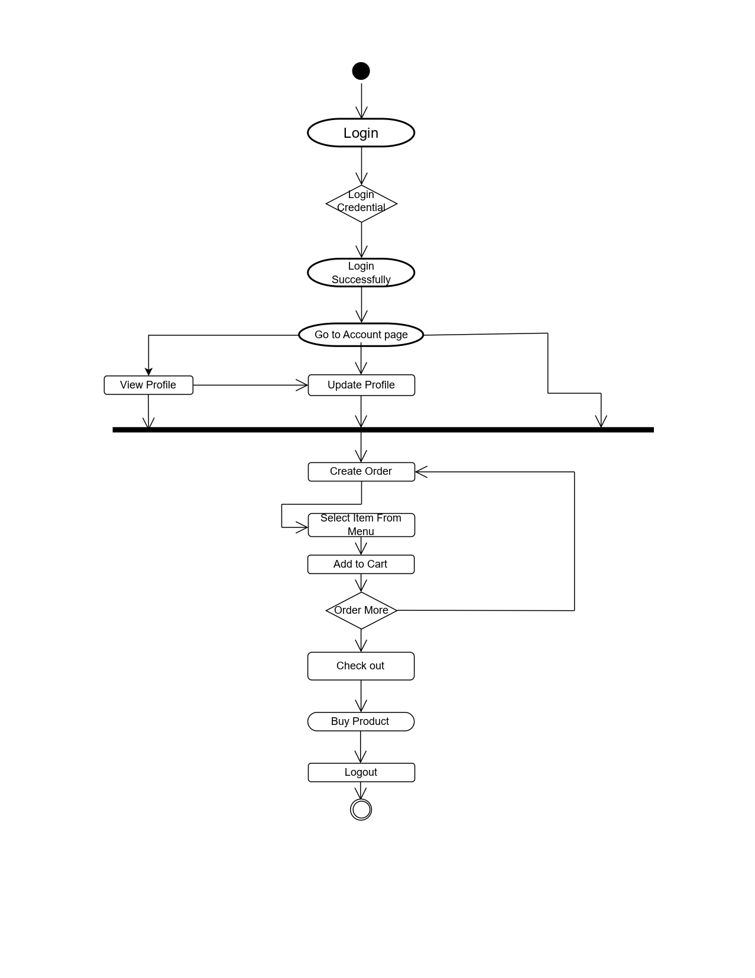

Activity Diagram

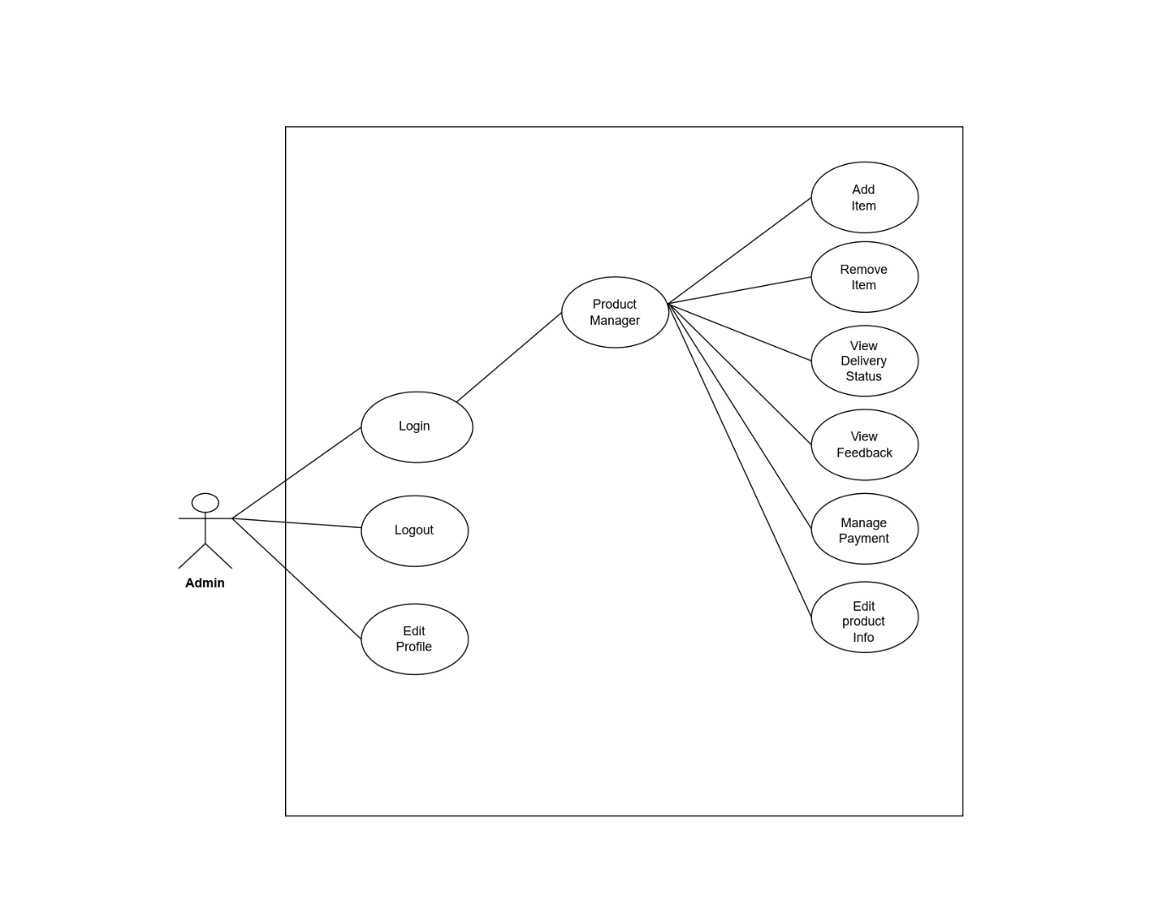

**Admin side Use case diagram**

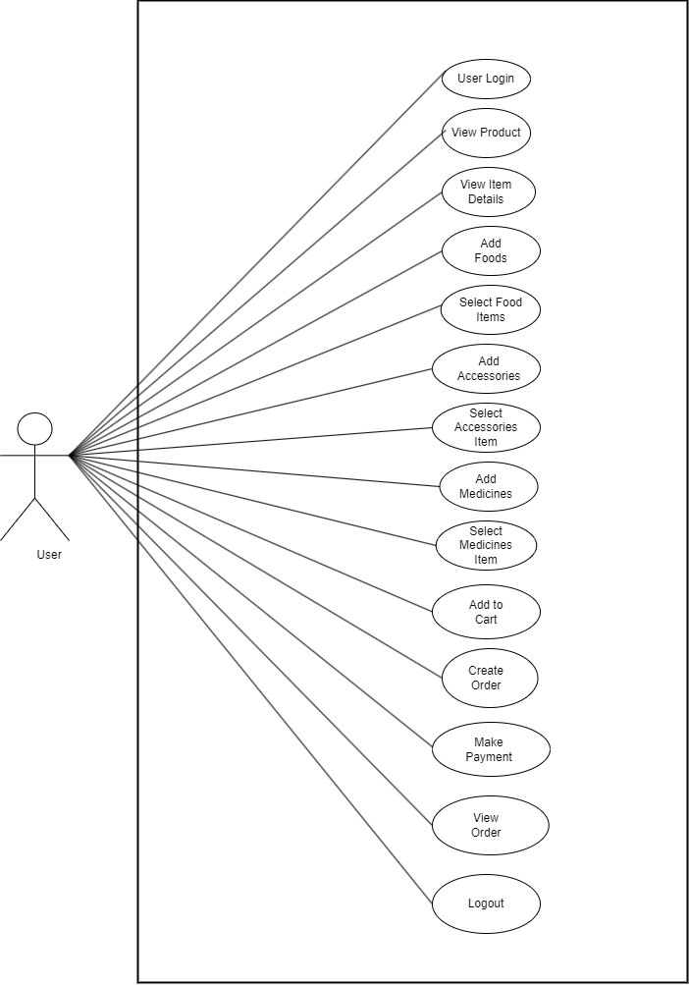

Admin side Use case diagram

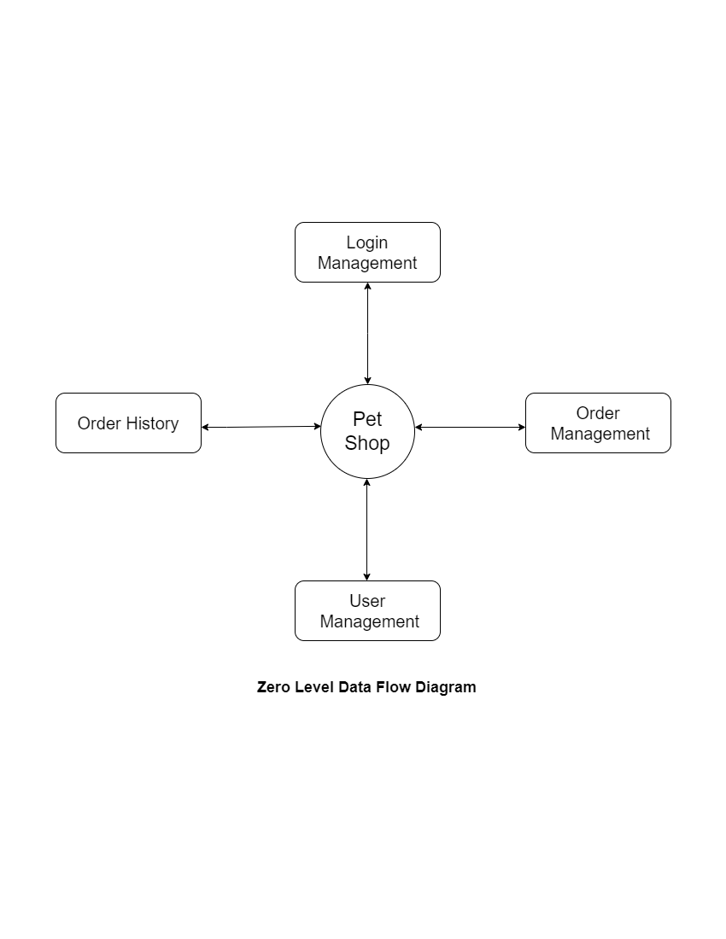

# *Figure 7.0 Level DFD*

# *Figure 7 1 Level DFD*

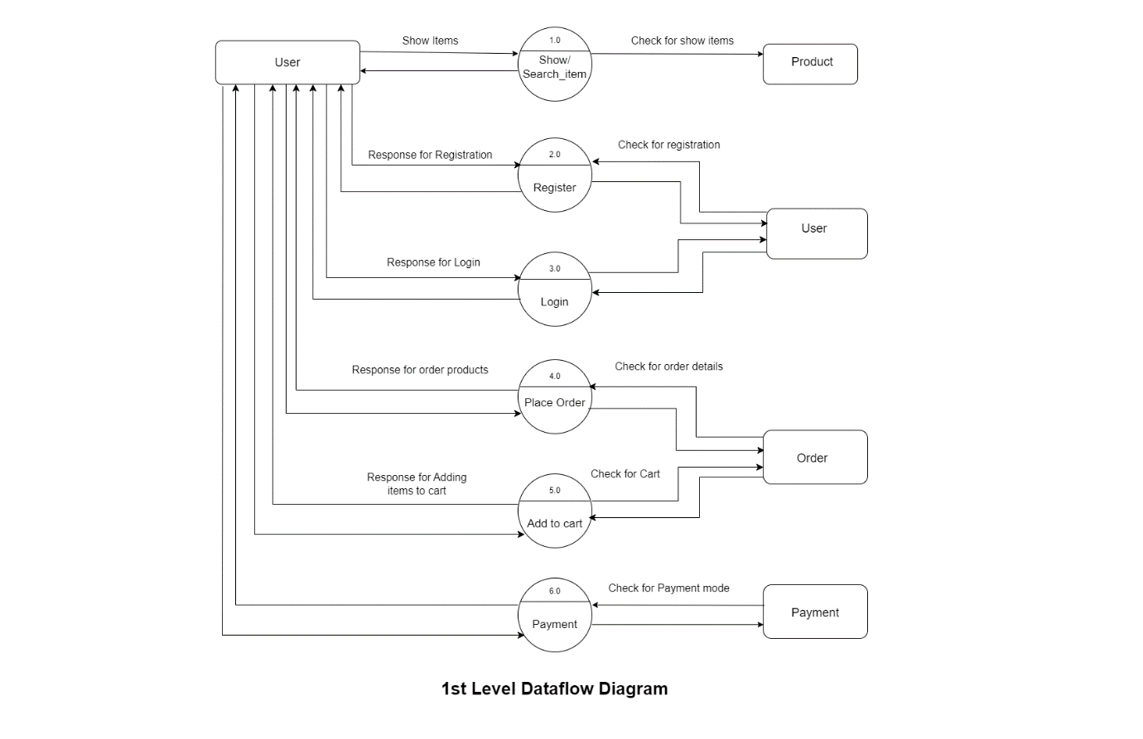

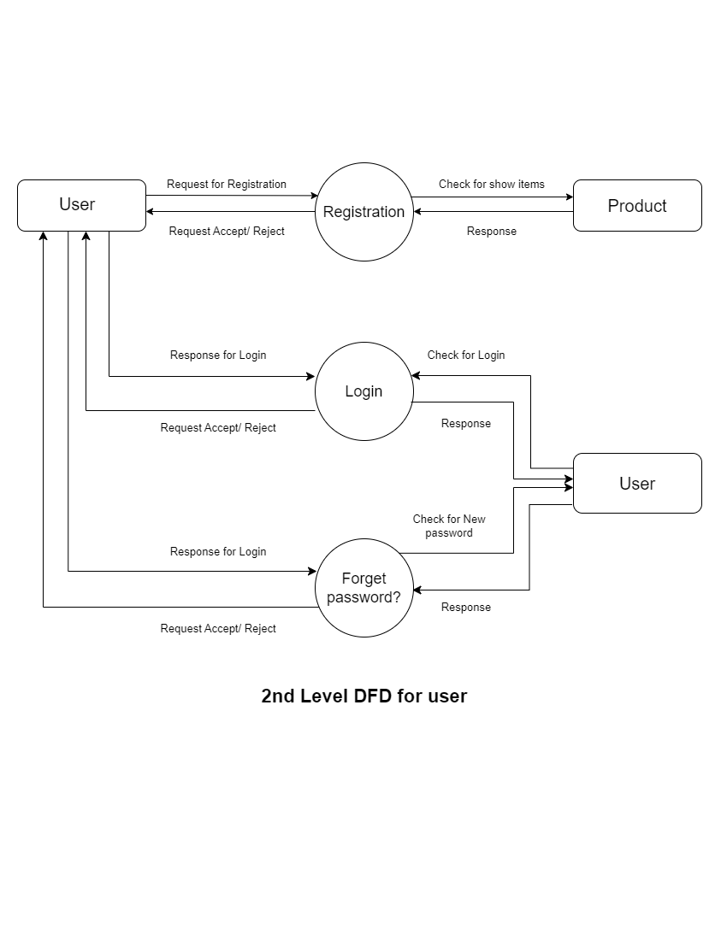

# *Figure 7 2 Level DFD for user*

# 

# *Figure 7 3 Level DFD for Admin*

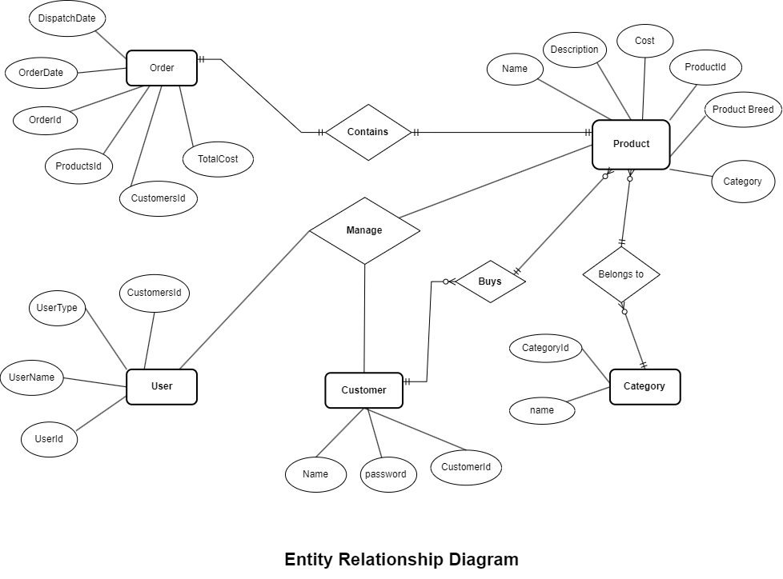

# **ER Diagram and Class Diagram**

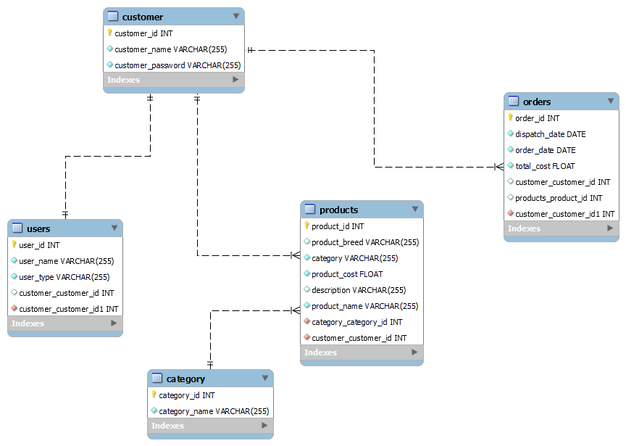

1. 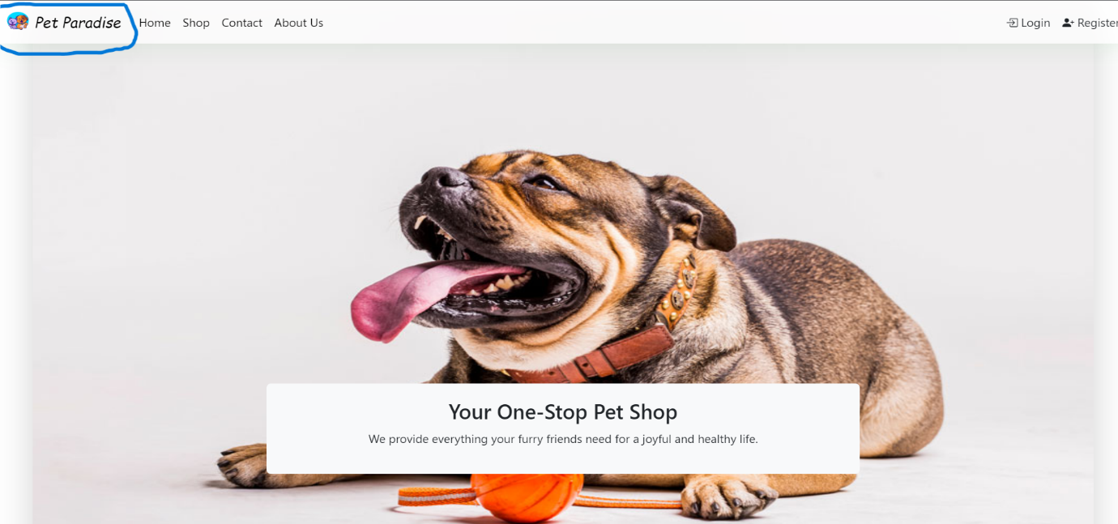**PetShop - HomePage**
2. **LoginPage**

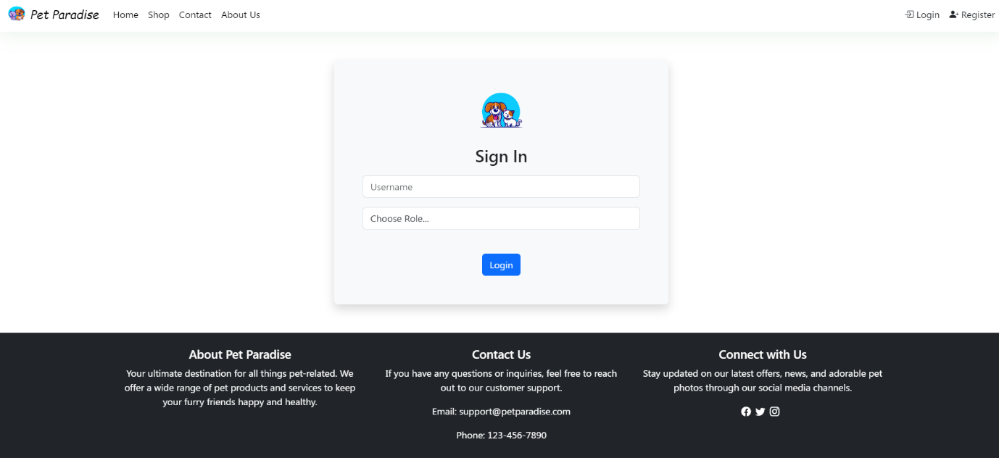

1. **Registration**

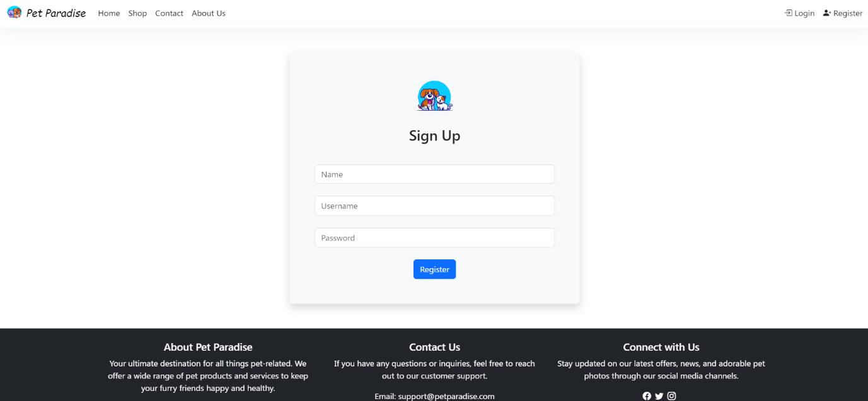

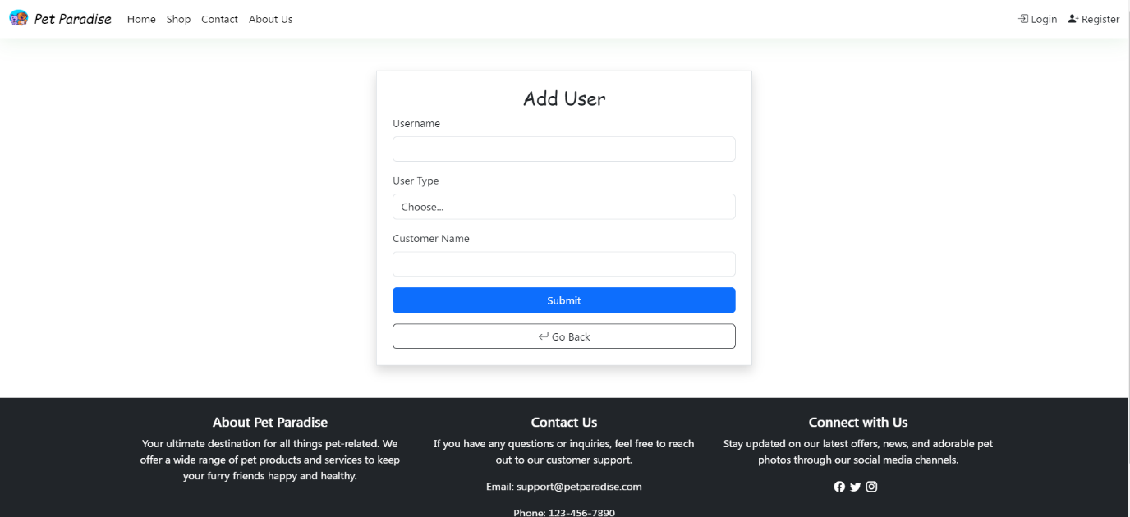

1. 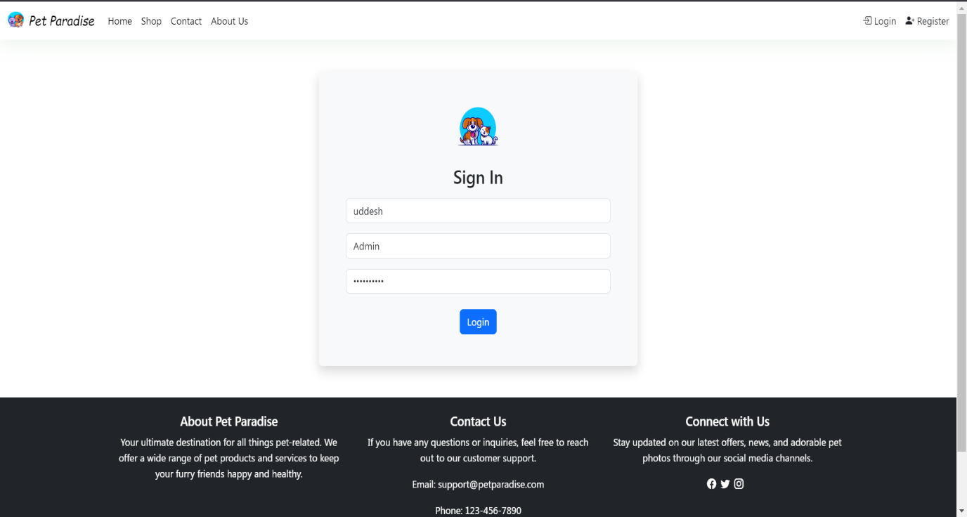**AdminLogin**
2. **AddCustomers**

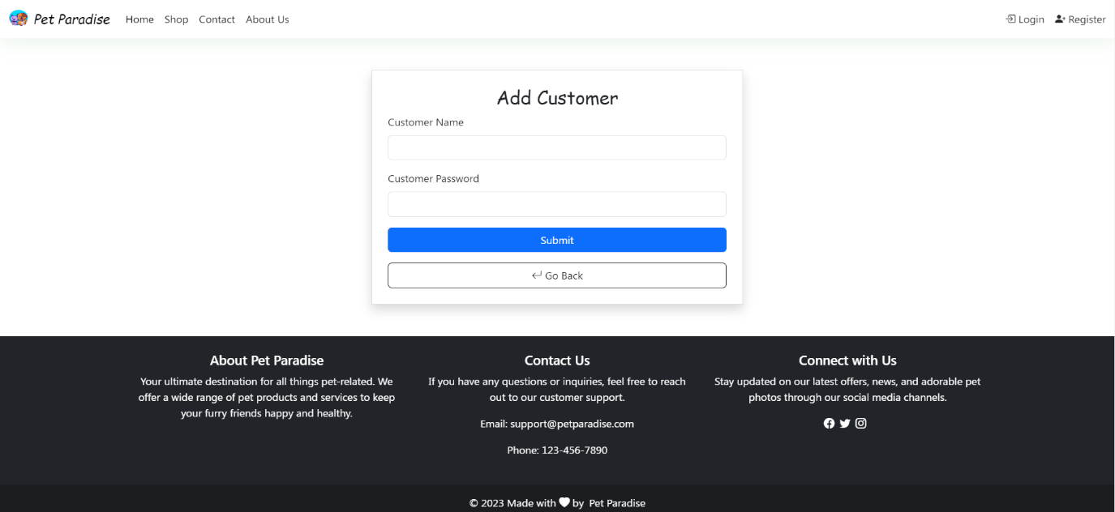

1. **AddProducts**

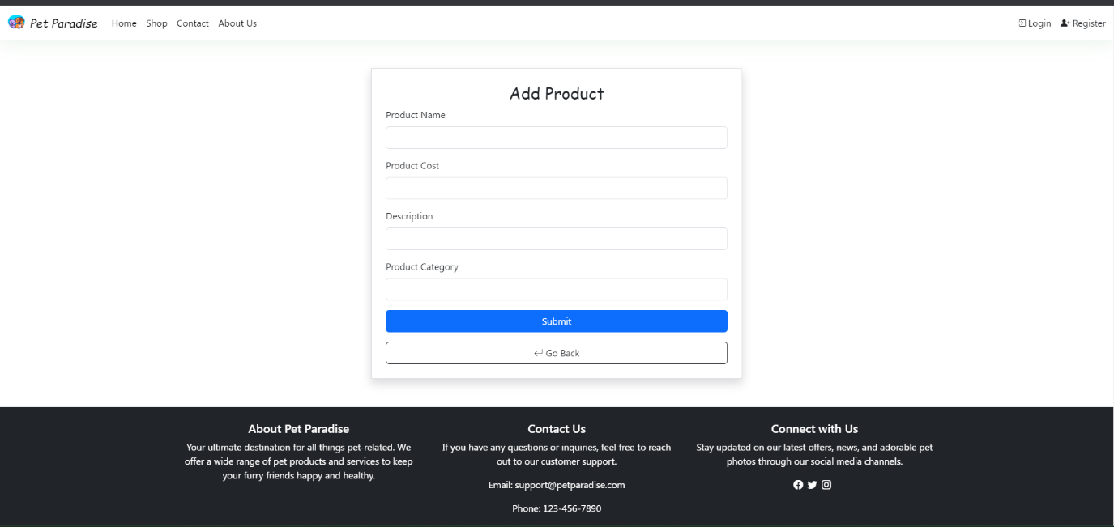

1. **Available Products**

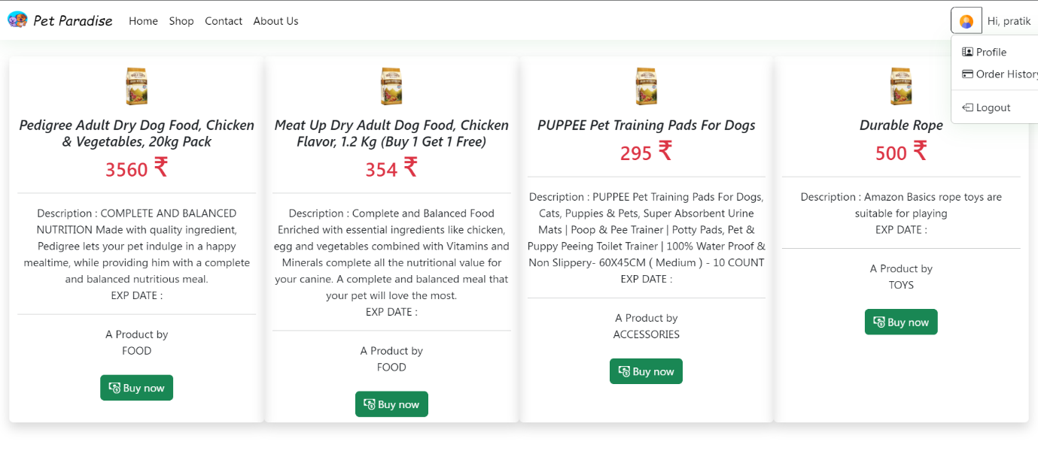

1. **Customer Profile**

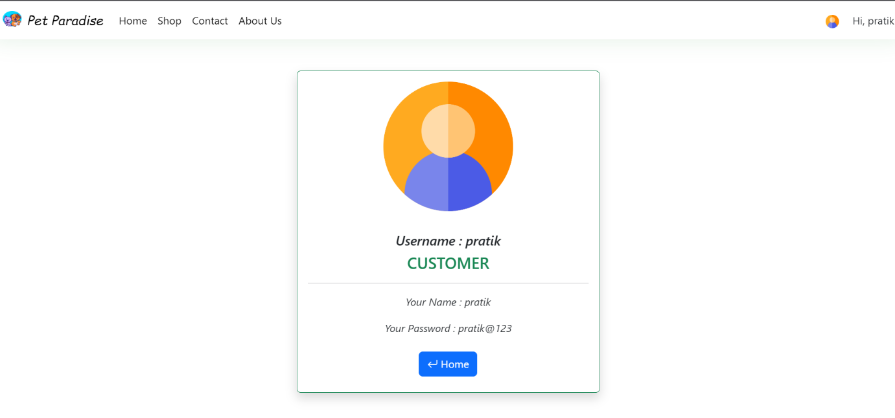

1. **Admin Profile**

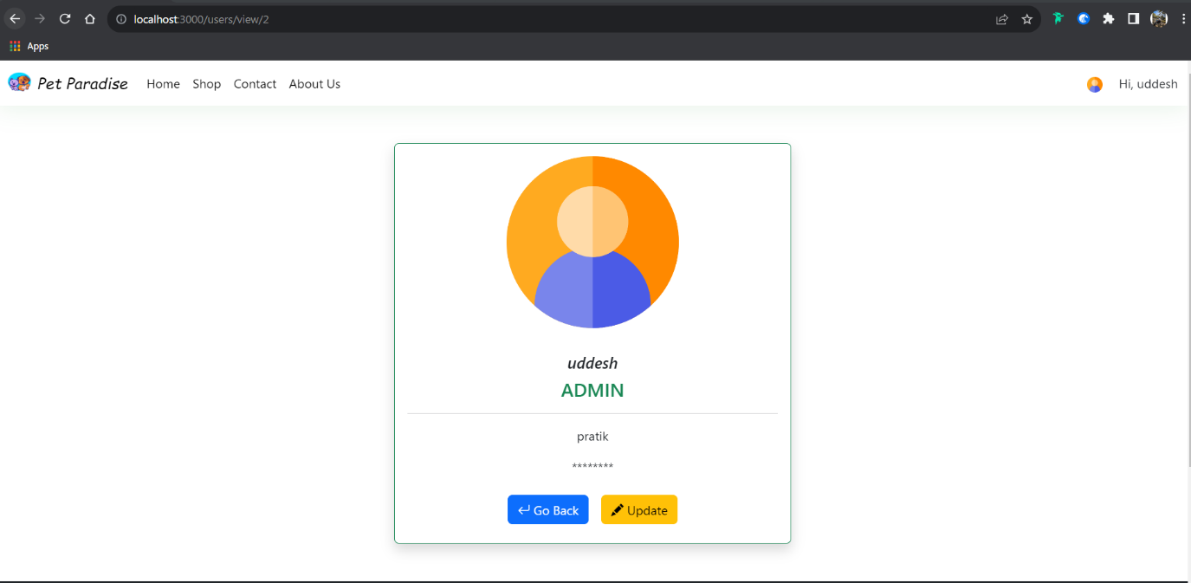

1. **Admin User Control**

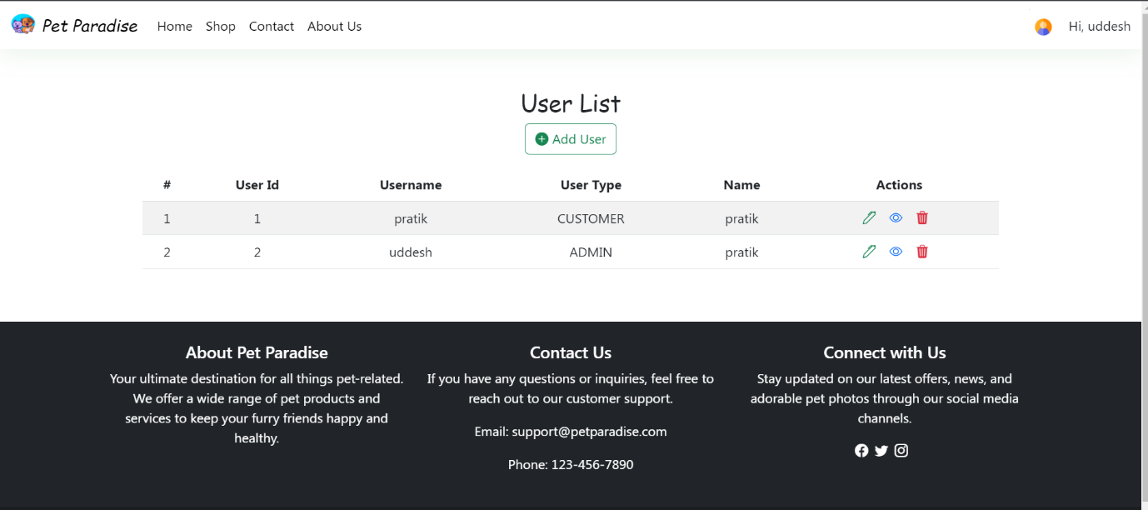

1. **CustomerBuyingProduct**

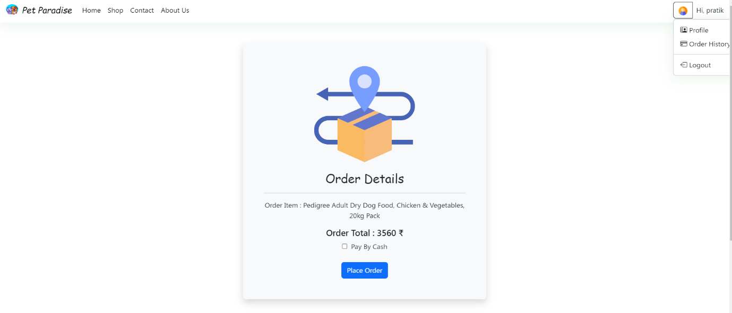

1. **Customer Order History**

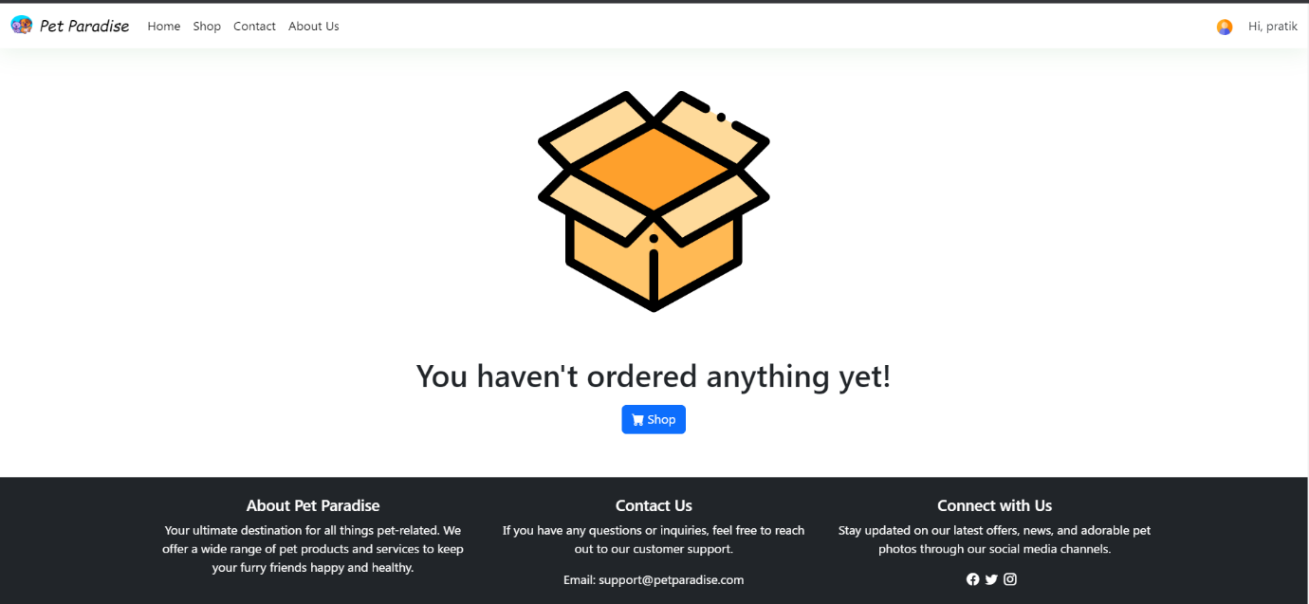

1. **Order Placed**

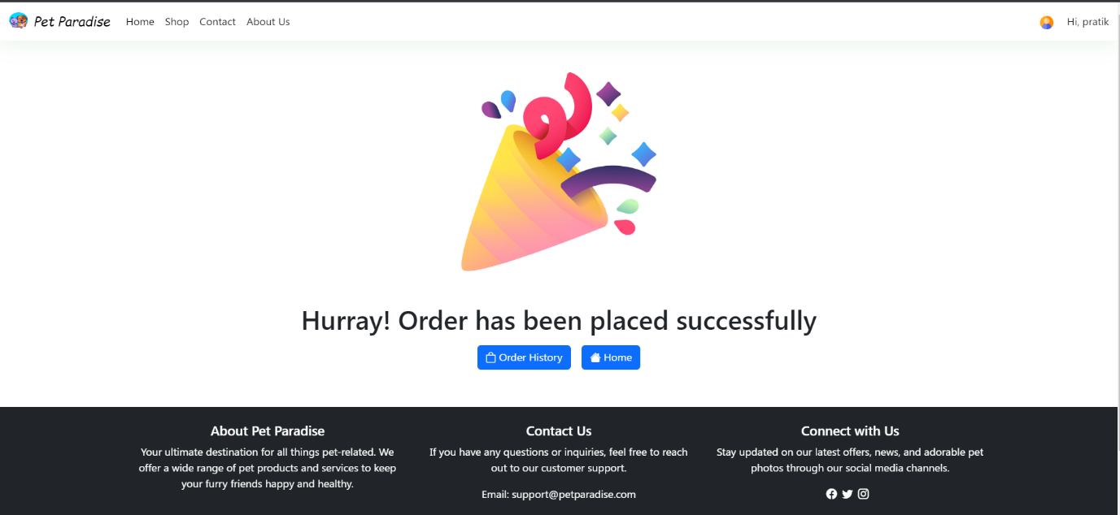

1. **ViewCustomerDetailsById**

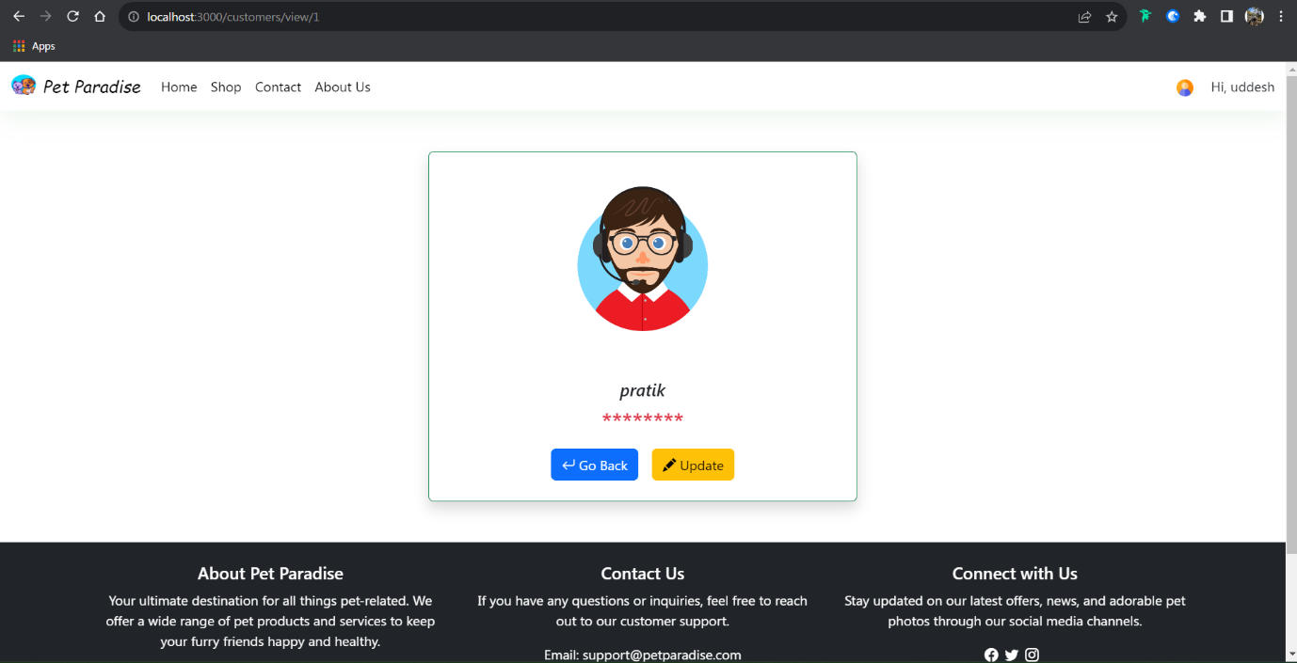

1. **ViewOrderDetailsById**

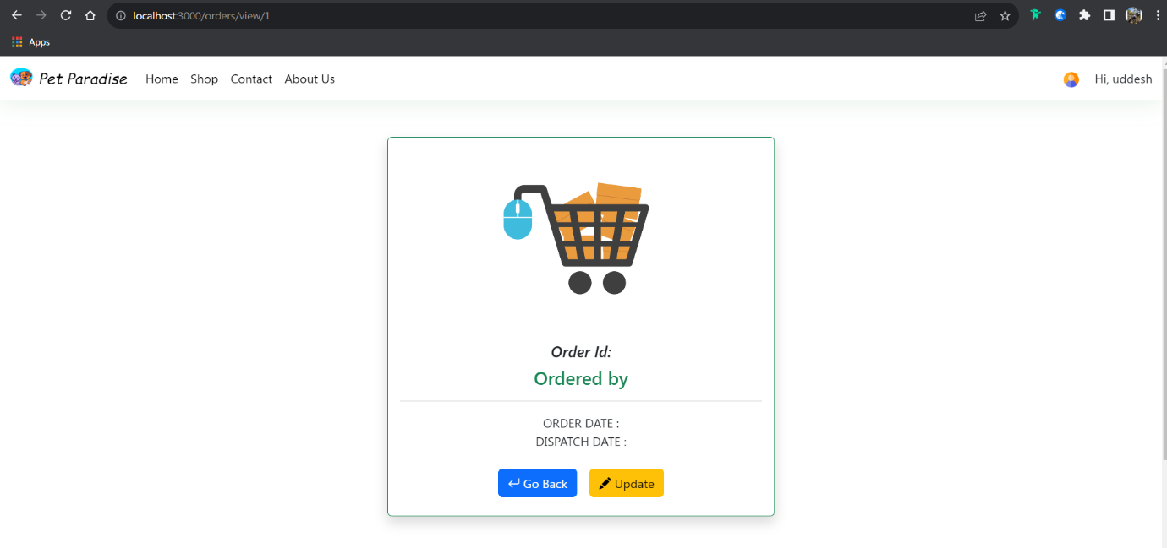

1. **ViewProductDetailsById**

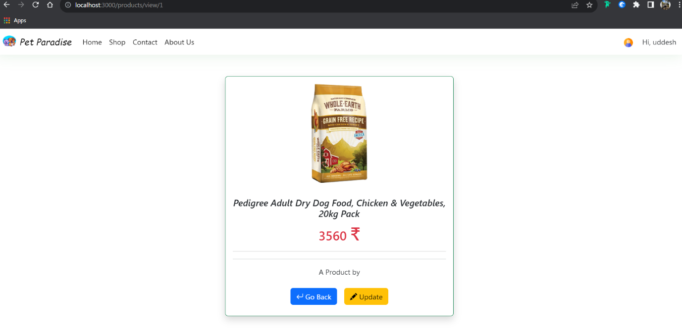

1. **ViewUserDetailsByID**

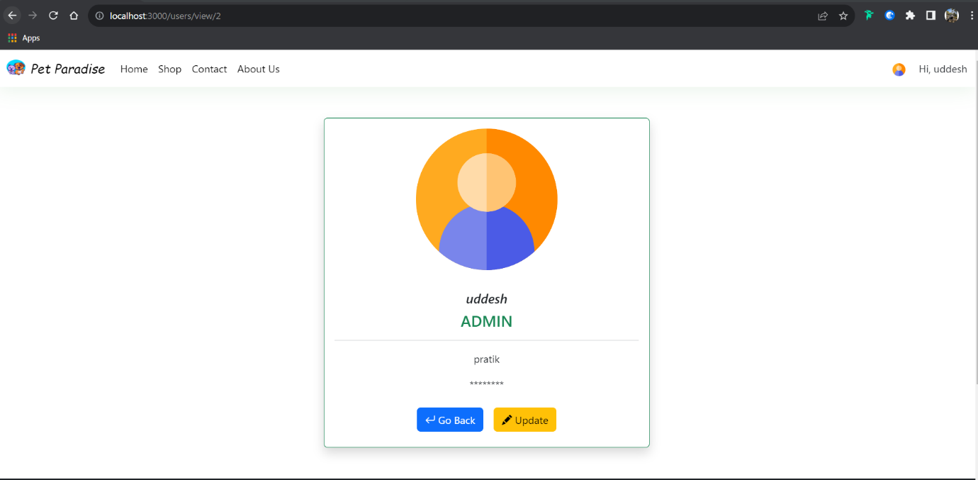

1. **Petblog**

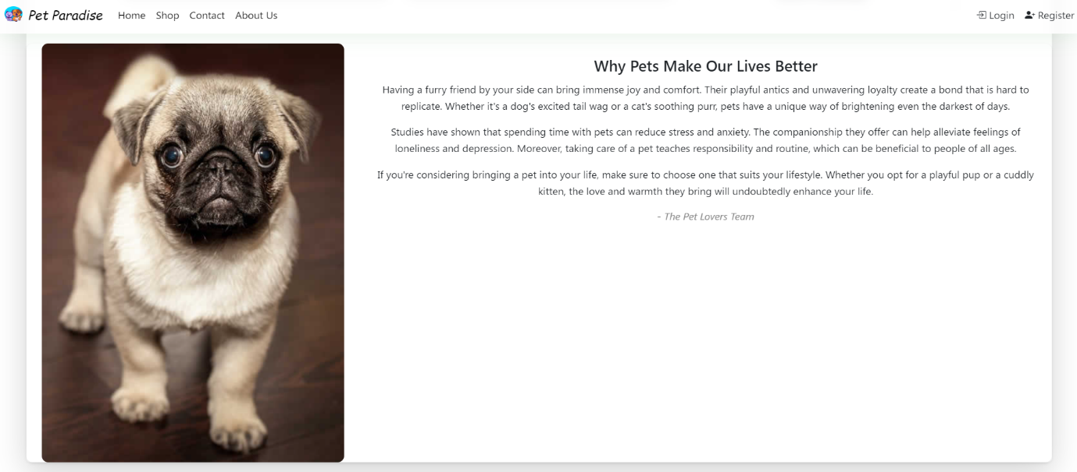

1. **UnauthorizedPage**

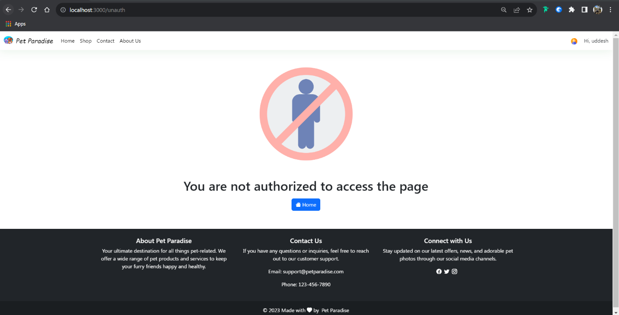

1. **UpdateCustomerDetailsById**

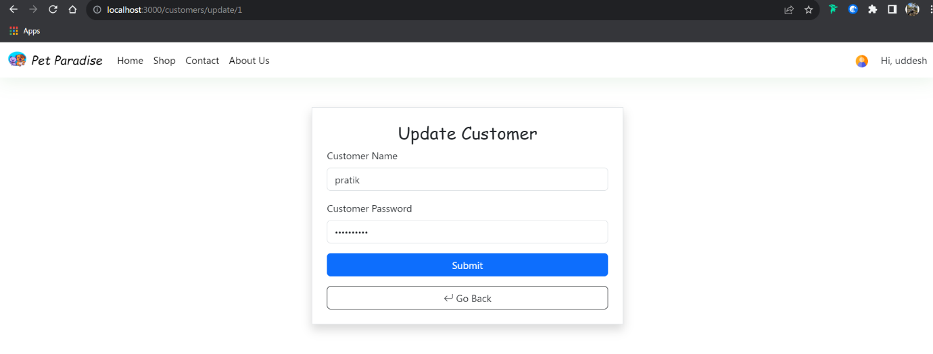

1. **UpdateOrderDetailsByID**

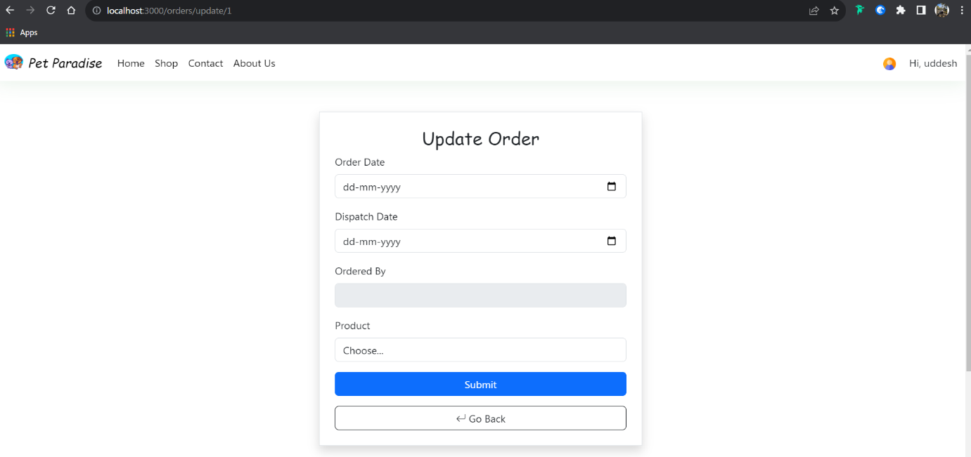

1. **UpdateProductById**

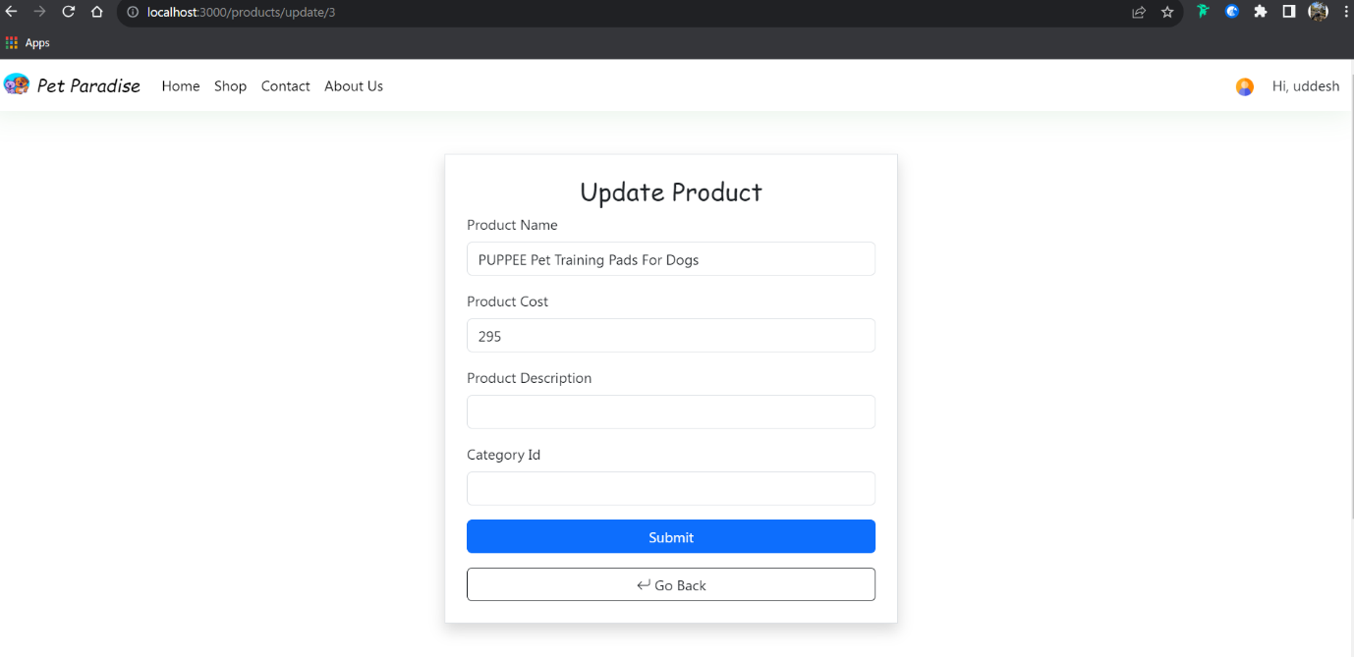

1. **UpdateUserDetailsByID**

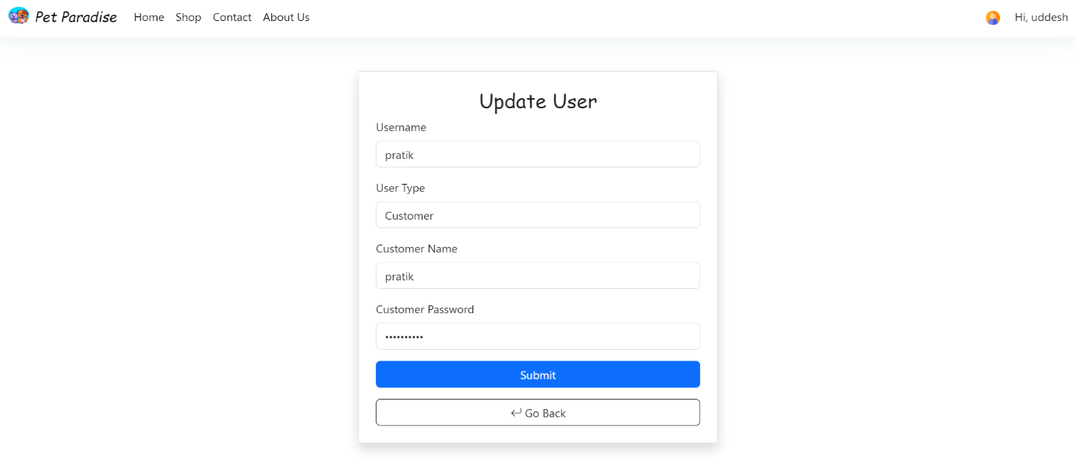

1. **Footer**

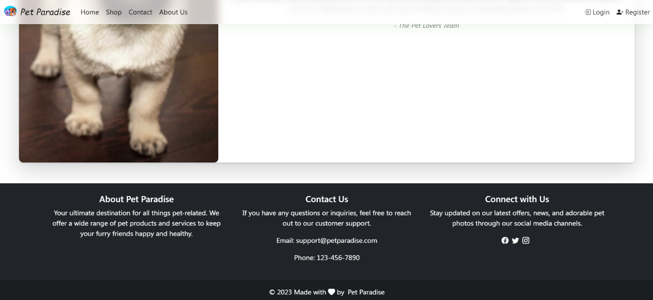

1. **AboutUS**

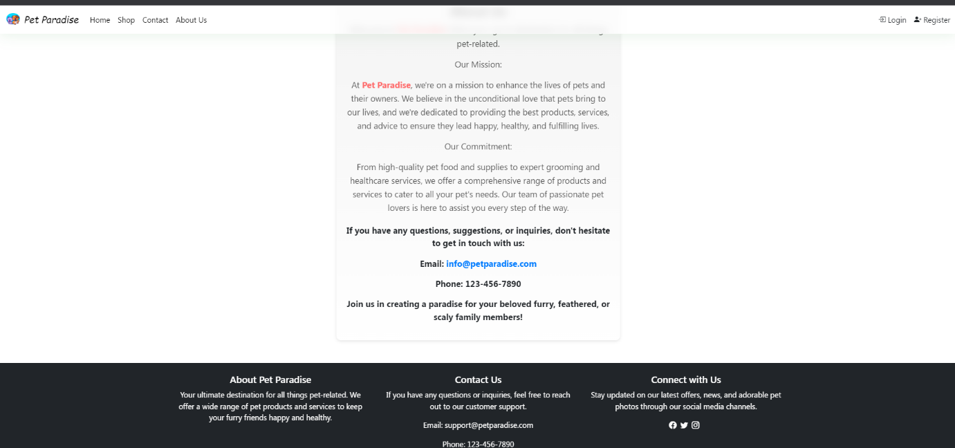

1. **ConcatctUS**

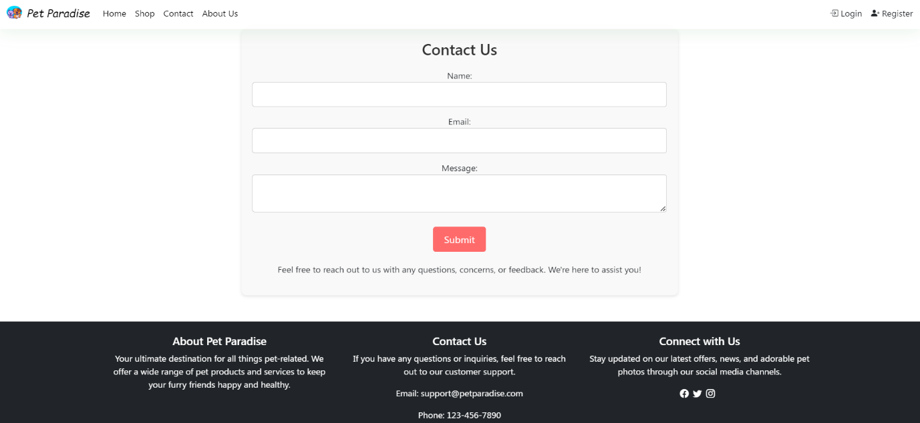

1. **PageNotFound**

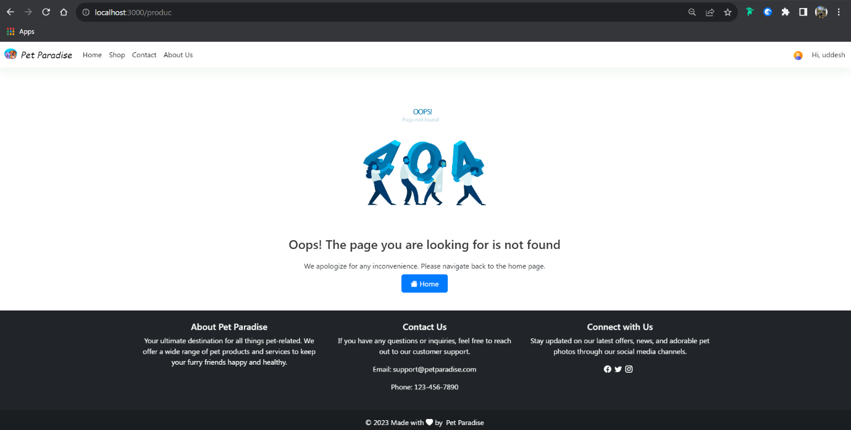

**CONCLUSION**

In conclusion, the Pet Shop Web Application harmonizes technology with pet enthusiasts' needs, revolutionizing the pet shopping experience. By offering customers a user-friendly interface, customizable choices, and secure transactions, the application redefines convenience. It empowers administrators with efficient tools, allowing them to manage products and orders effectively. This project not only bridges the gap between traditional pet shops and online platforms but also sets a precedent for industry evolution. Through seamless shopping and streamlined management, the Pet Shop Web Application showcases technology's potential to reshape and enhance industries.

**Resources and References**

**W3Schools (https://www.w3schools.com):** This resource provided valuable insights into web development technologies and practices, enhancing the application's frontend design and functionality.

**GitHub (https://www.github.com):** GitHub served as a pivotal platform for collaborative development and version control, enabling seamless teamwork and code management.

**Node.js Documentation (https://nodejs.org/en/docs):** The Node.js documentation proved essential in understanding and implementing backend functionalities, ensuring efficient server-side operations.

**Oracle Documentation (https://docs.oracle.com):** The Oracle documentation played a significant role in enhancing the project's database design and management, enabling effective data storage and retrieval.

**Spring Boot Documentation (https://docs.spring.io/spring-boot/docs/current/reference/htmlsingle/):** The Spring Boot documentation served as a comprehensive guide in utilizing Spring Boot framework to create robust backend systems, facilitating seamless integration and efficient data handling.

**Java EE Documentation (https://docs.oracle.com/javaee/6/):** The Java EE documentation informed the project's architecture and coding practices, ensuring adherence to industry standards and best practices.